**1. What is MSM, blueprint, live copy and rollout?**

**Multi-Site Manager (MSM)**:

MSM is a feature in AEM that allows you to manage and control multiple websites from a single source.

It helps create a consistent structure, content, and design across multiple sites.

MSM is commonly used to manage global sites with region-specific variations.

**Blueprint:**

A blueprint is the source site used to create and manage live copies.

It acts as the master site from which content is copied to child sites.

Changes made in the blueprint can be rolled out to the live copies.

**Live Copy:**

A live copy is a copy of the source content (blueprint) that can be synchronized with it.

It maintains a reference to the source and receives updates through rollouts.

You can apply modifications specific to the live copy while still inheriting updates from the source.

**Rollout:**

A rollout is the process of pushing changes from the blueprint to the live copies.

You can choose the level of synchronization (full, partial, or custom).

Rollouts ensure that child sites stay updated with changes made in the blueprint.

**2. What is language copy?**

A Language Copy is a site copy created for translation purposes.

It does not maintain a live relationship with the source (unlike live copies).

It allows content authors to create localized versions of pages by translating the content into different languages.

**3. Create a site using MSM and us/en should be the source.**

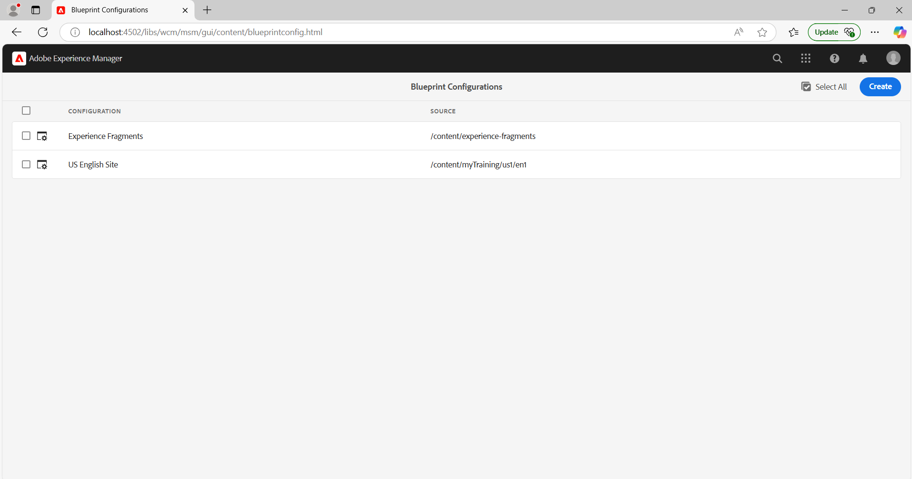

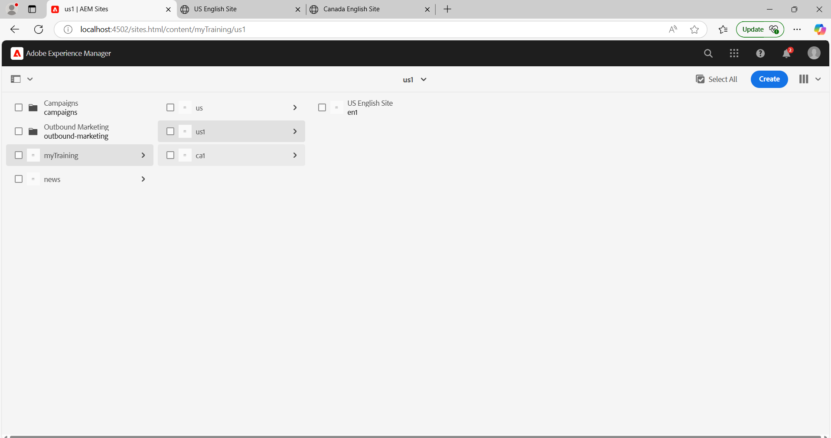

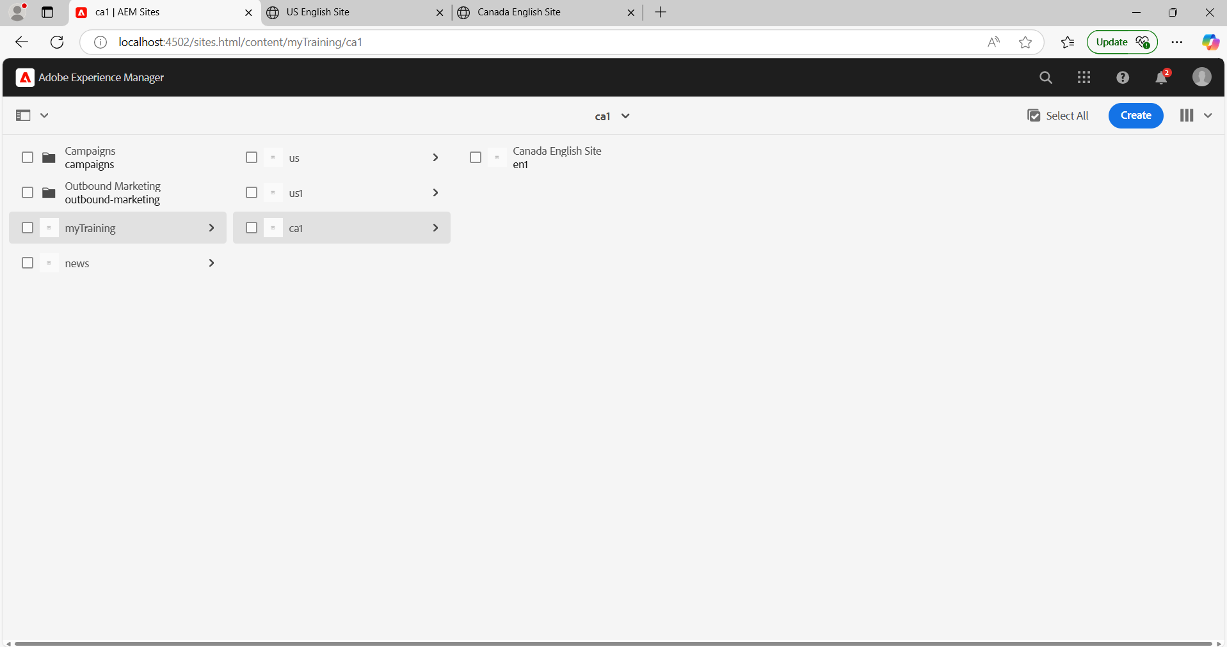

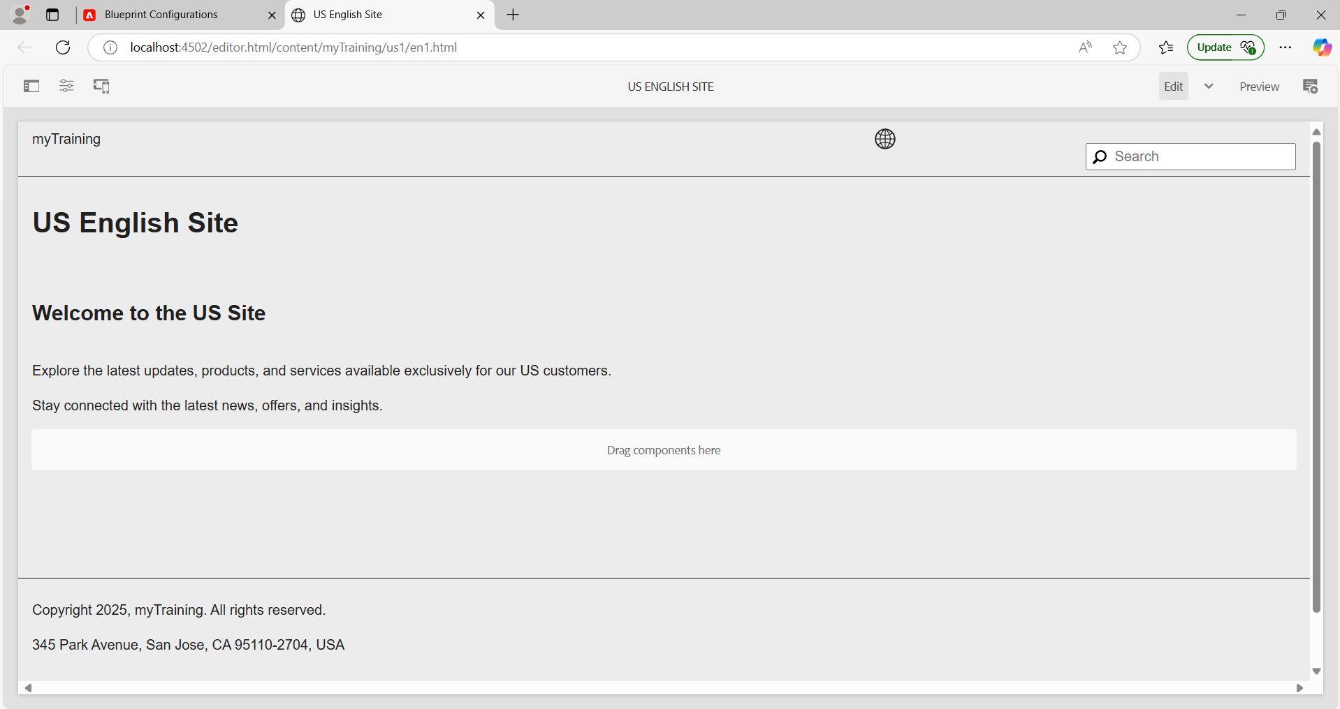

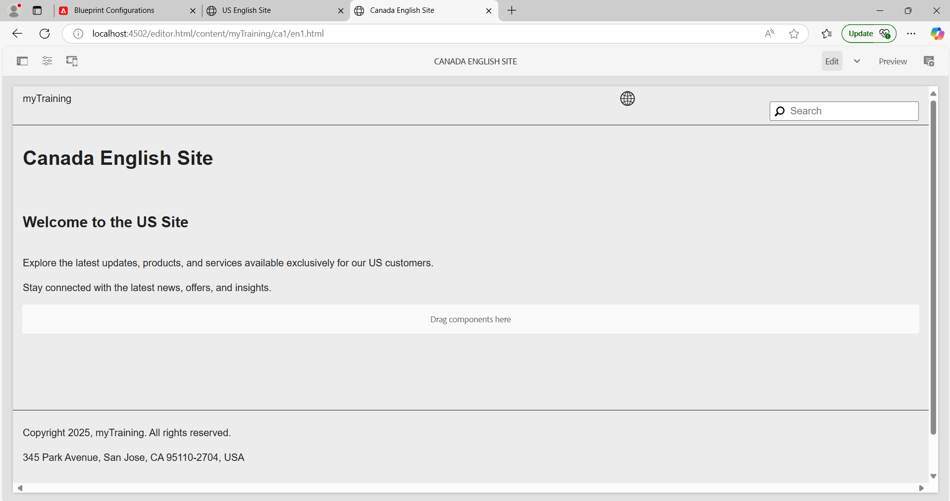

**4. Create this page** [**https://www.mcdonalds.com/us/en-us/about-our-food.html**](https://www.mcdonalds.com/us/en-us/about-our-food.html) **and author the page using components(using the content/images from the above page).**

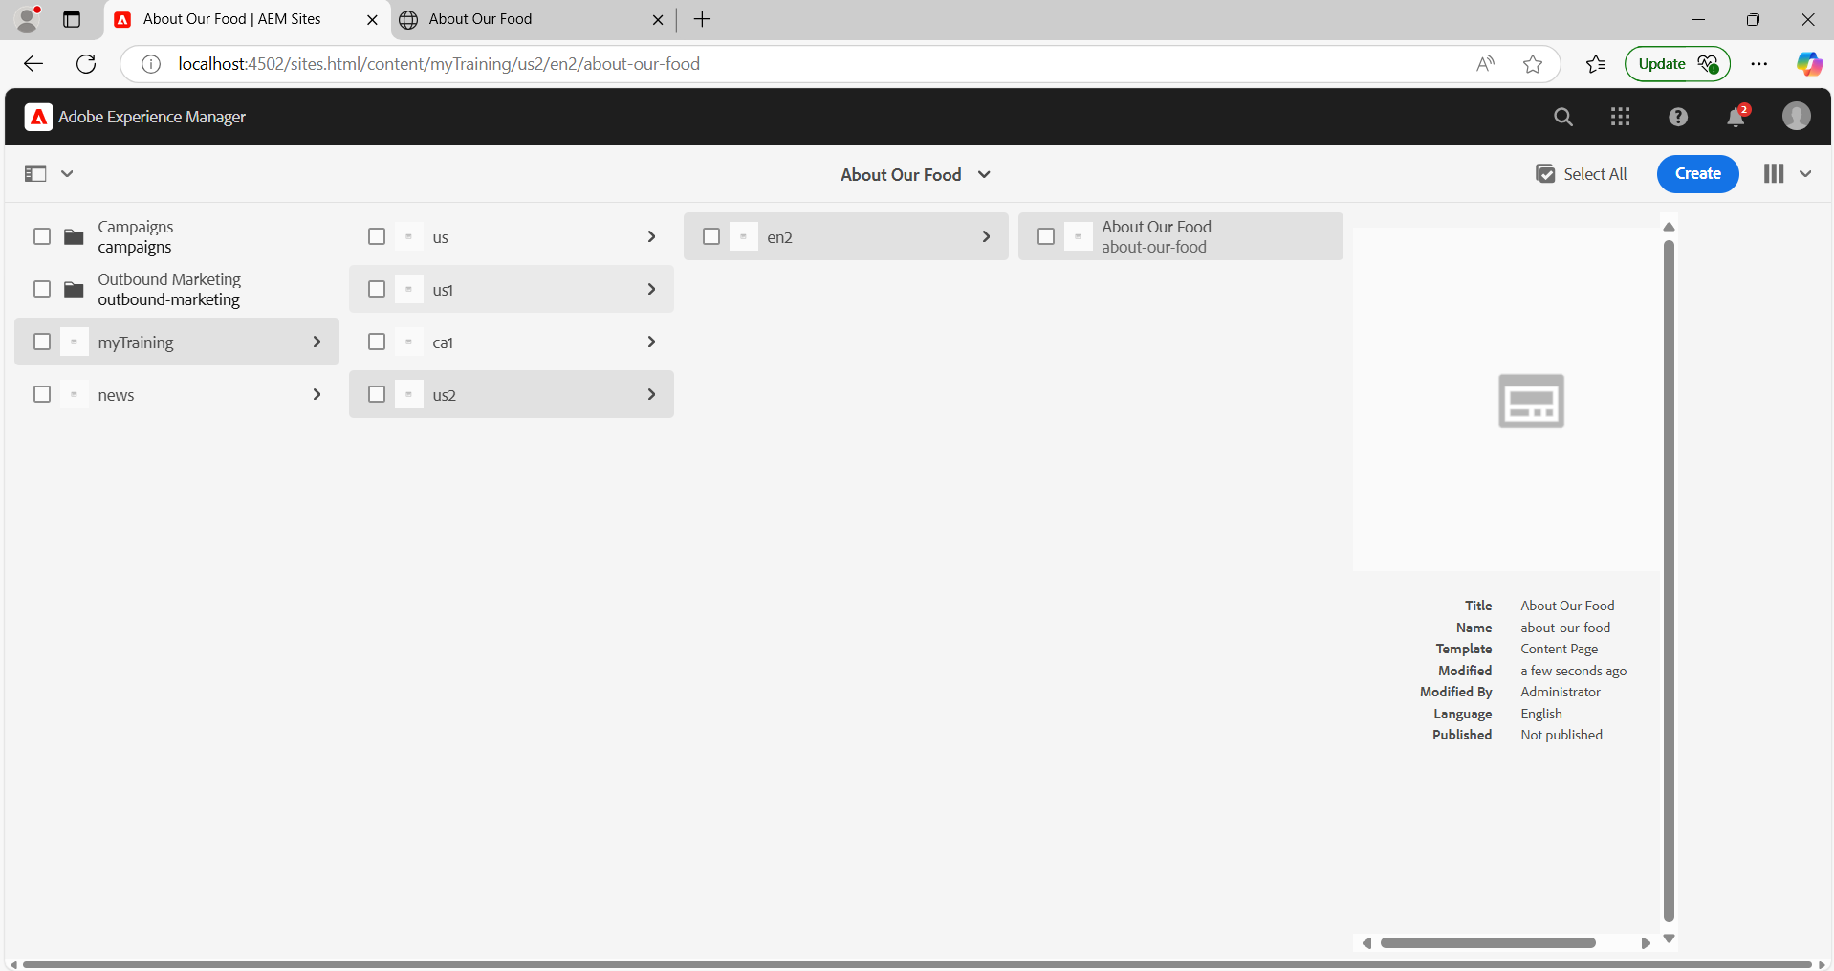

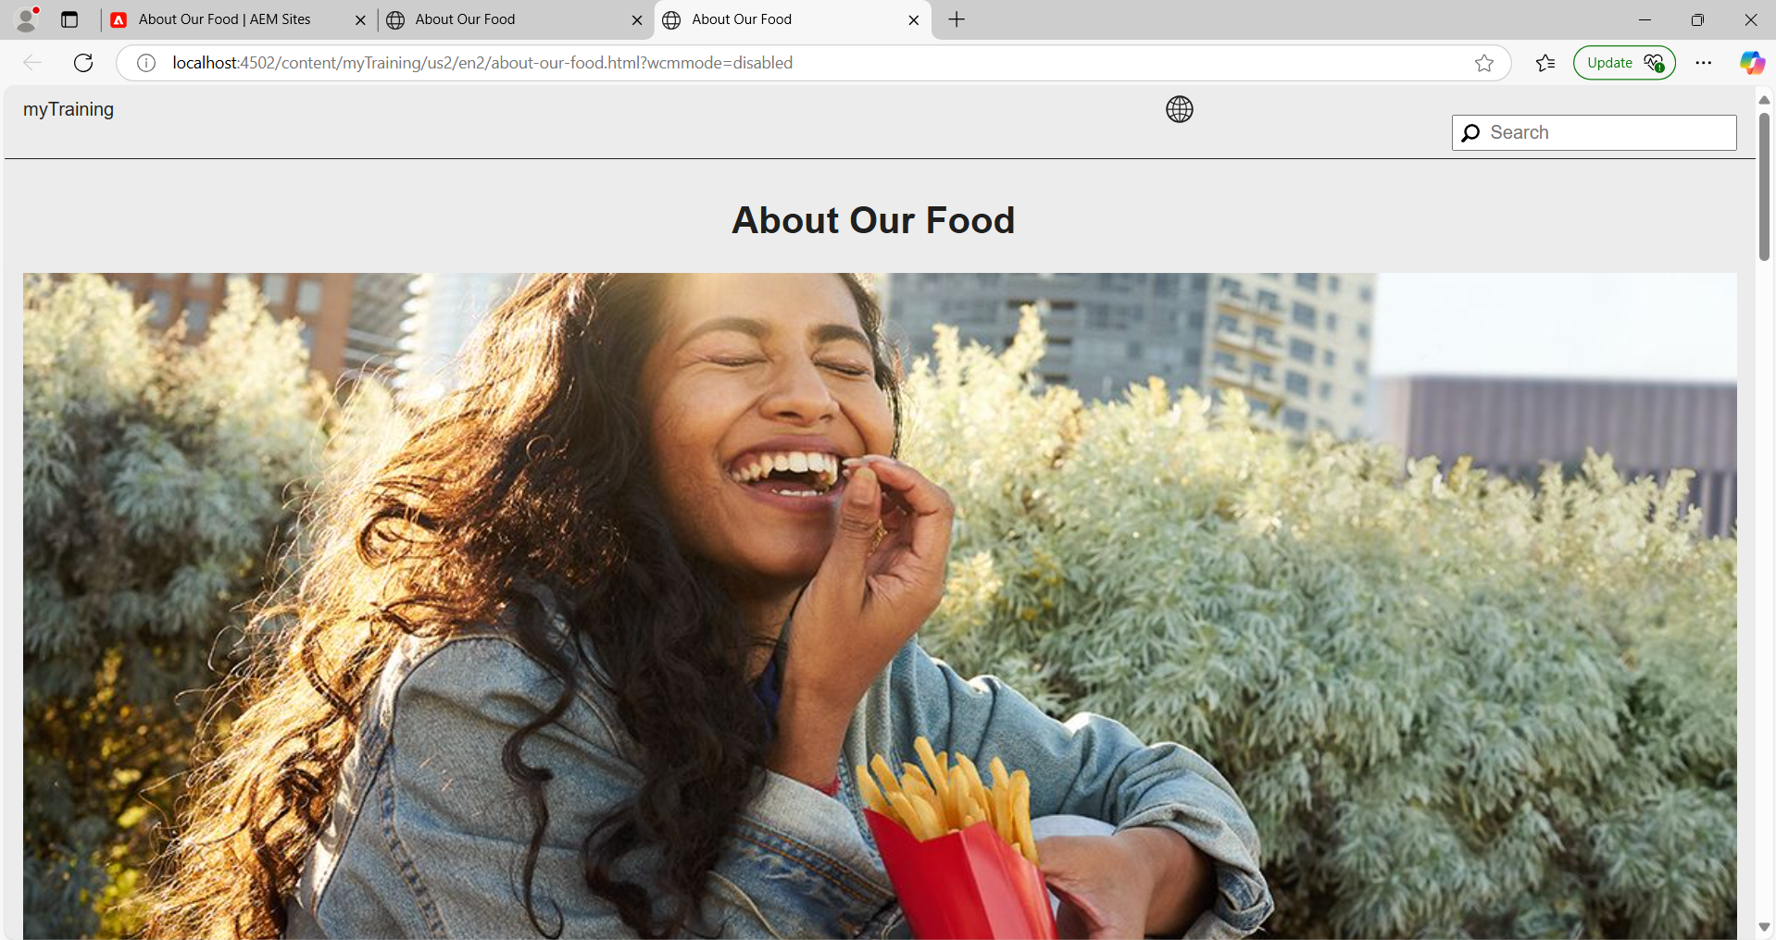

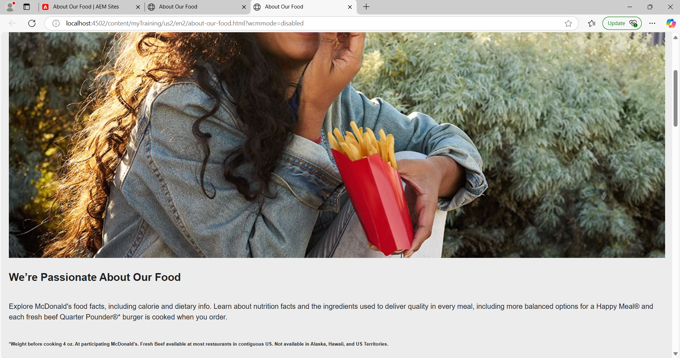

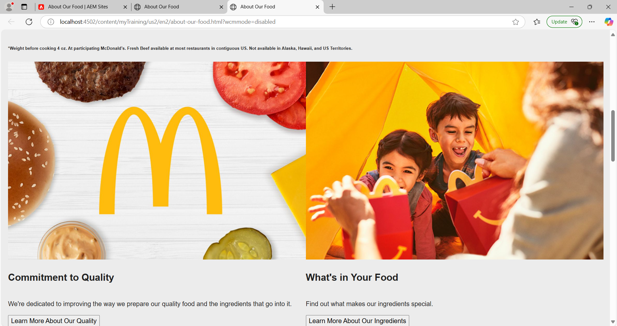

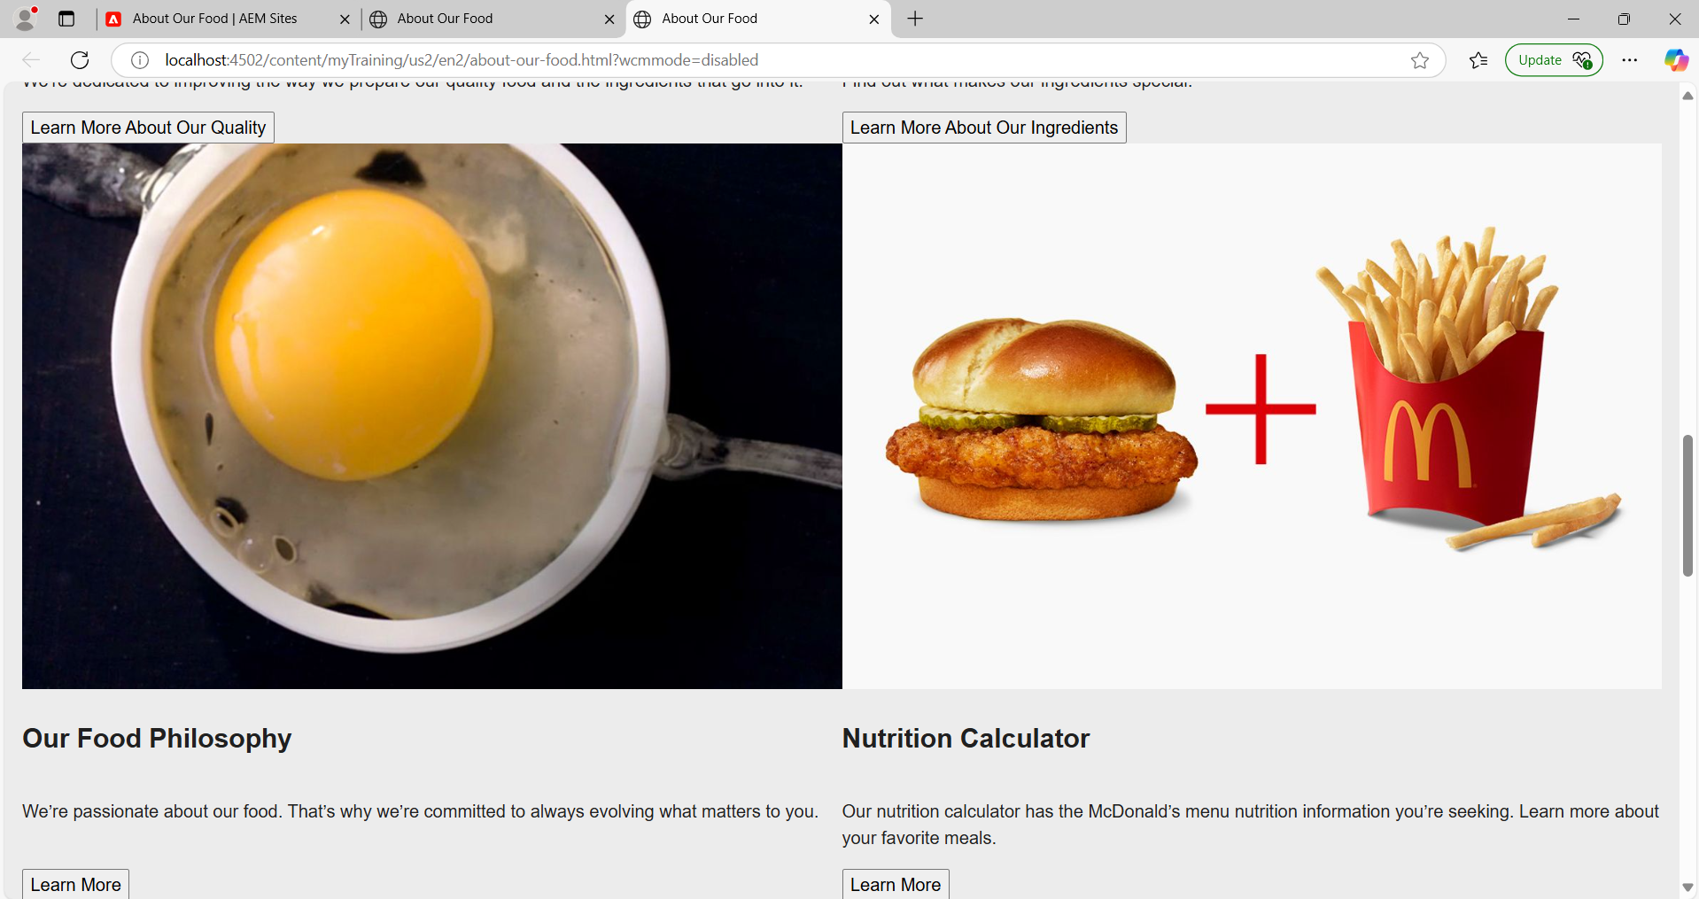

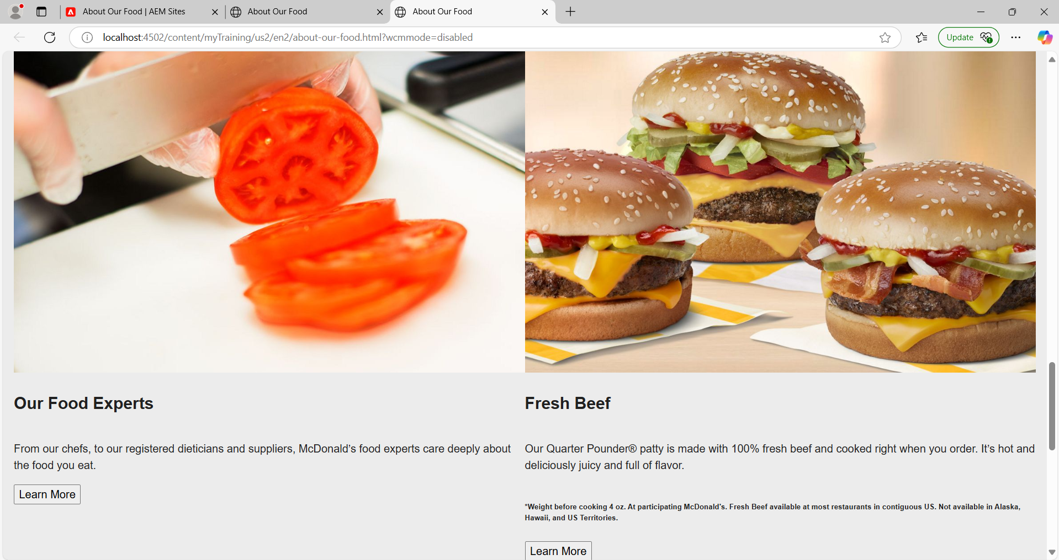

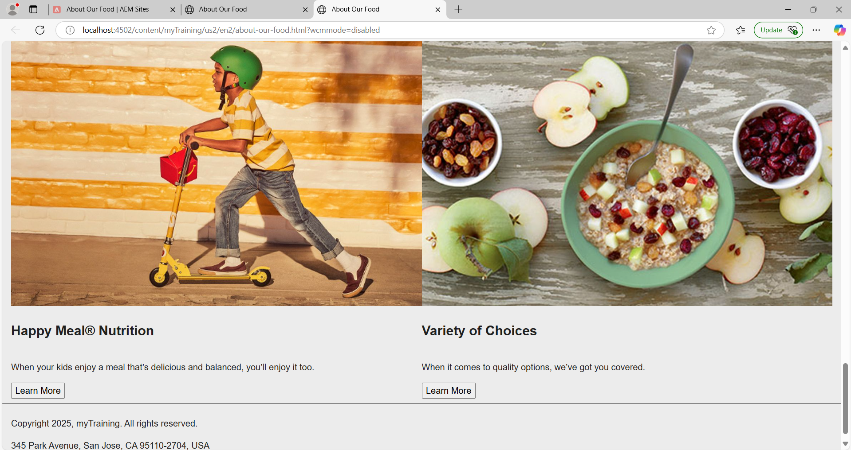

**5. Start the dispatcher on your local references.**

